**Wilkinson Splitter/ Combiner Design**

Brendan Bramman, UWaterloo/IQC

April, 2018

**Introduction**

This document explains how to design an RF Wilkinson splitter or Combiner. This PCB will allow you to combine or split equally any number of radiofrequency signals from 100MHz up to 20GHz. The Senko Ion Trap group uses these boards to combine RF signals at different frequencies into one signal for AOM’s and EOM’s, or to split RF signals of a single frequency so that multiple AOM’s are modulated the same. This is especially useful for the AOM switches, which are all operated at 200MHz. One thing to note is that you should not design a splitter for optical paths which need individual control of the carrier wave. A dedicated frequency should be used for optical paths such as these.

**Splitter Design**

The following notes describe how to design a Wilkinson splitter PCB for a certain frequency. This design only works for x2, 4, 8, … splitters. For other splitters, look into star configuration Wilkinson splitters. Chapter 7 of David Pozar’s Microwave Engineering is a great reference for Wilkinson splitters. Saturn PCB Design can be downloaded here: <http://www.saturnpcb.com/pcb_toolkit.htm>

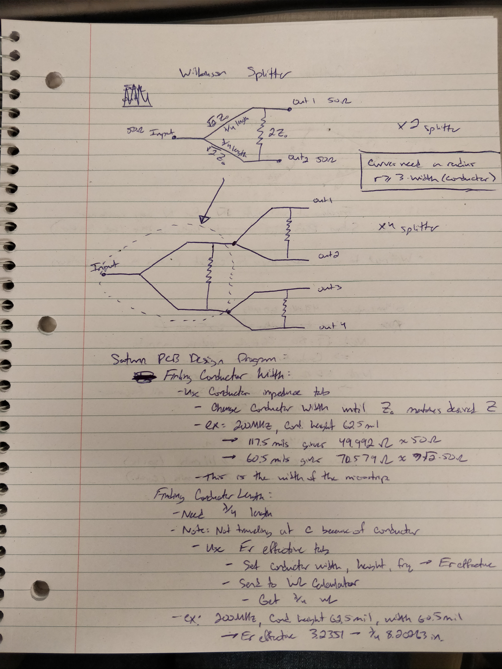

The Saturn PCB design parameters mentioned in these notes are shown in the following screenshots:

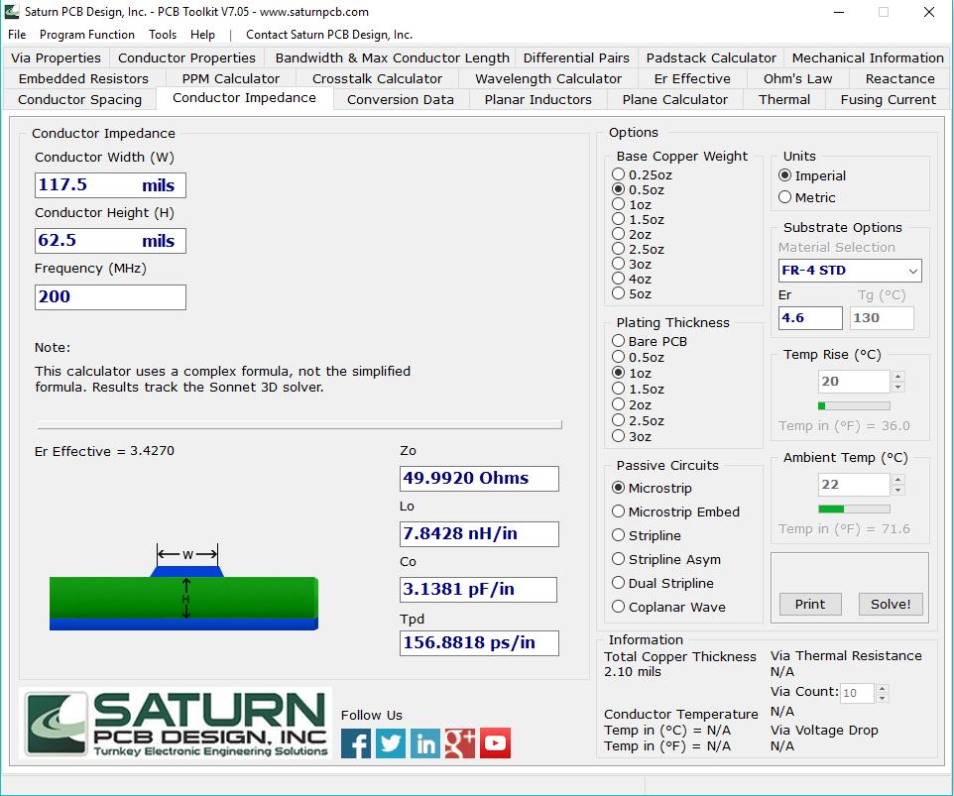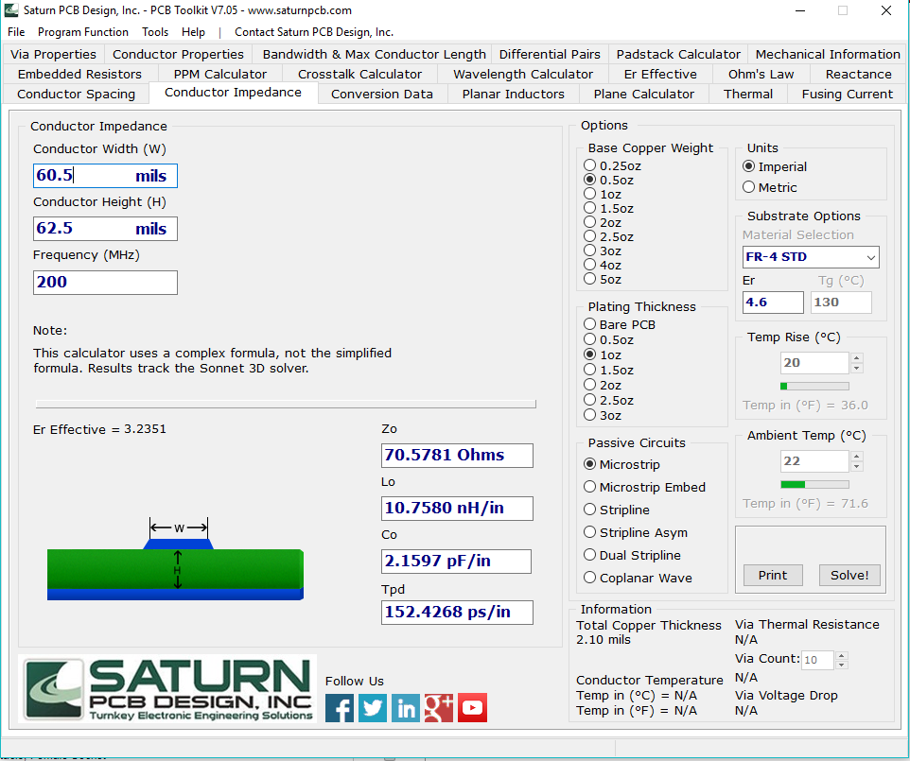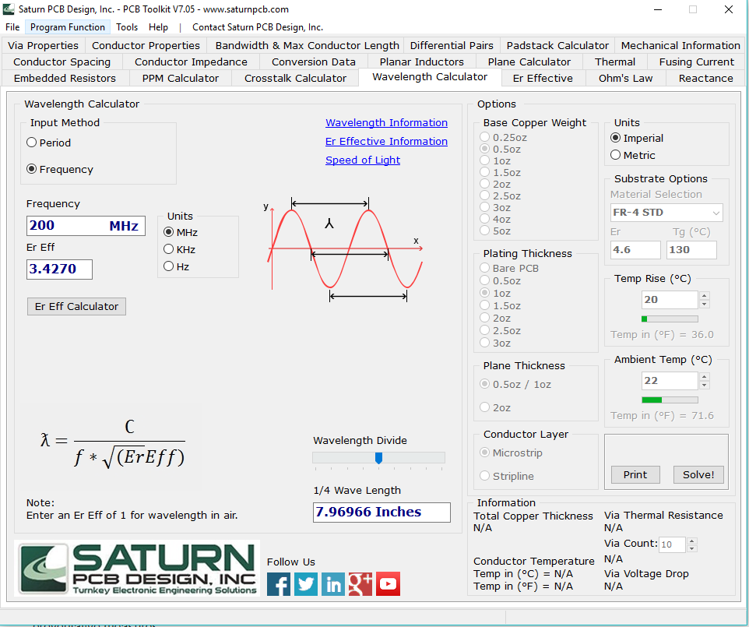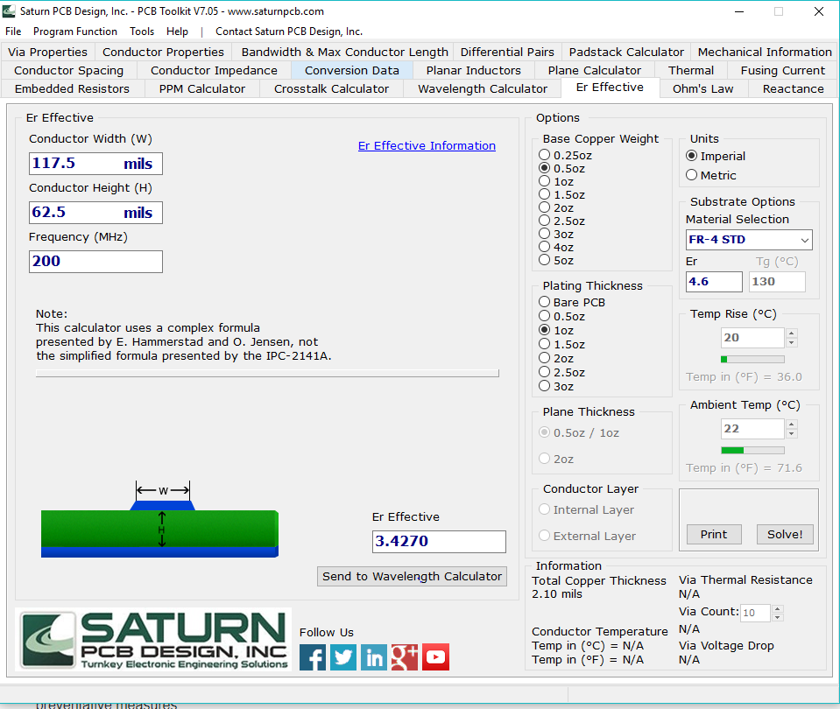

**Combiner Design**

The following notes describe how to design a Combiner to merge several different RF signals into one output signal. It uses the star configuration to combine 3 signals, and the generalization to N signals is explained. Parameters are found using Saturn PCB Design

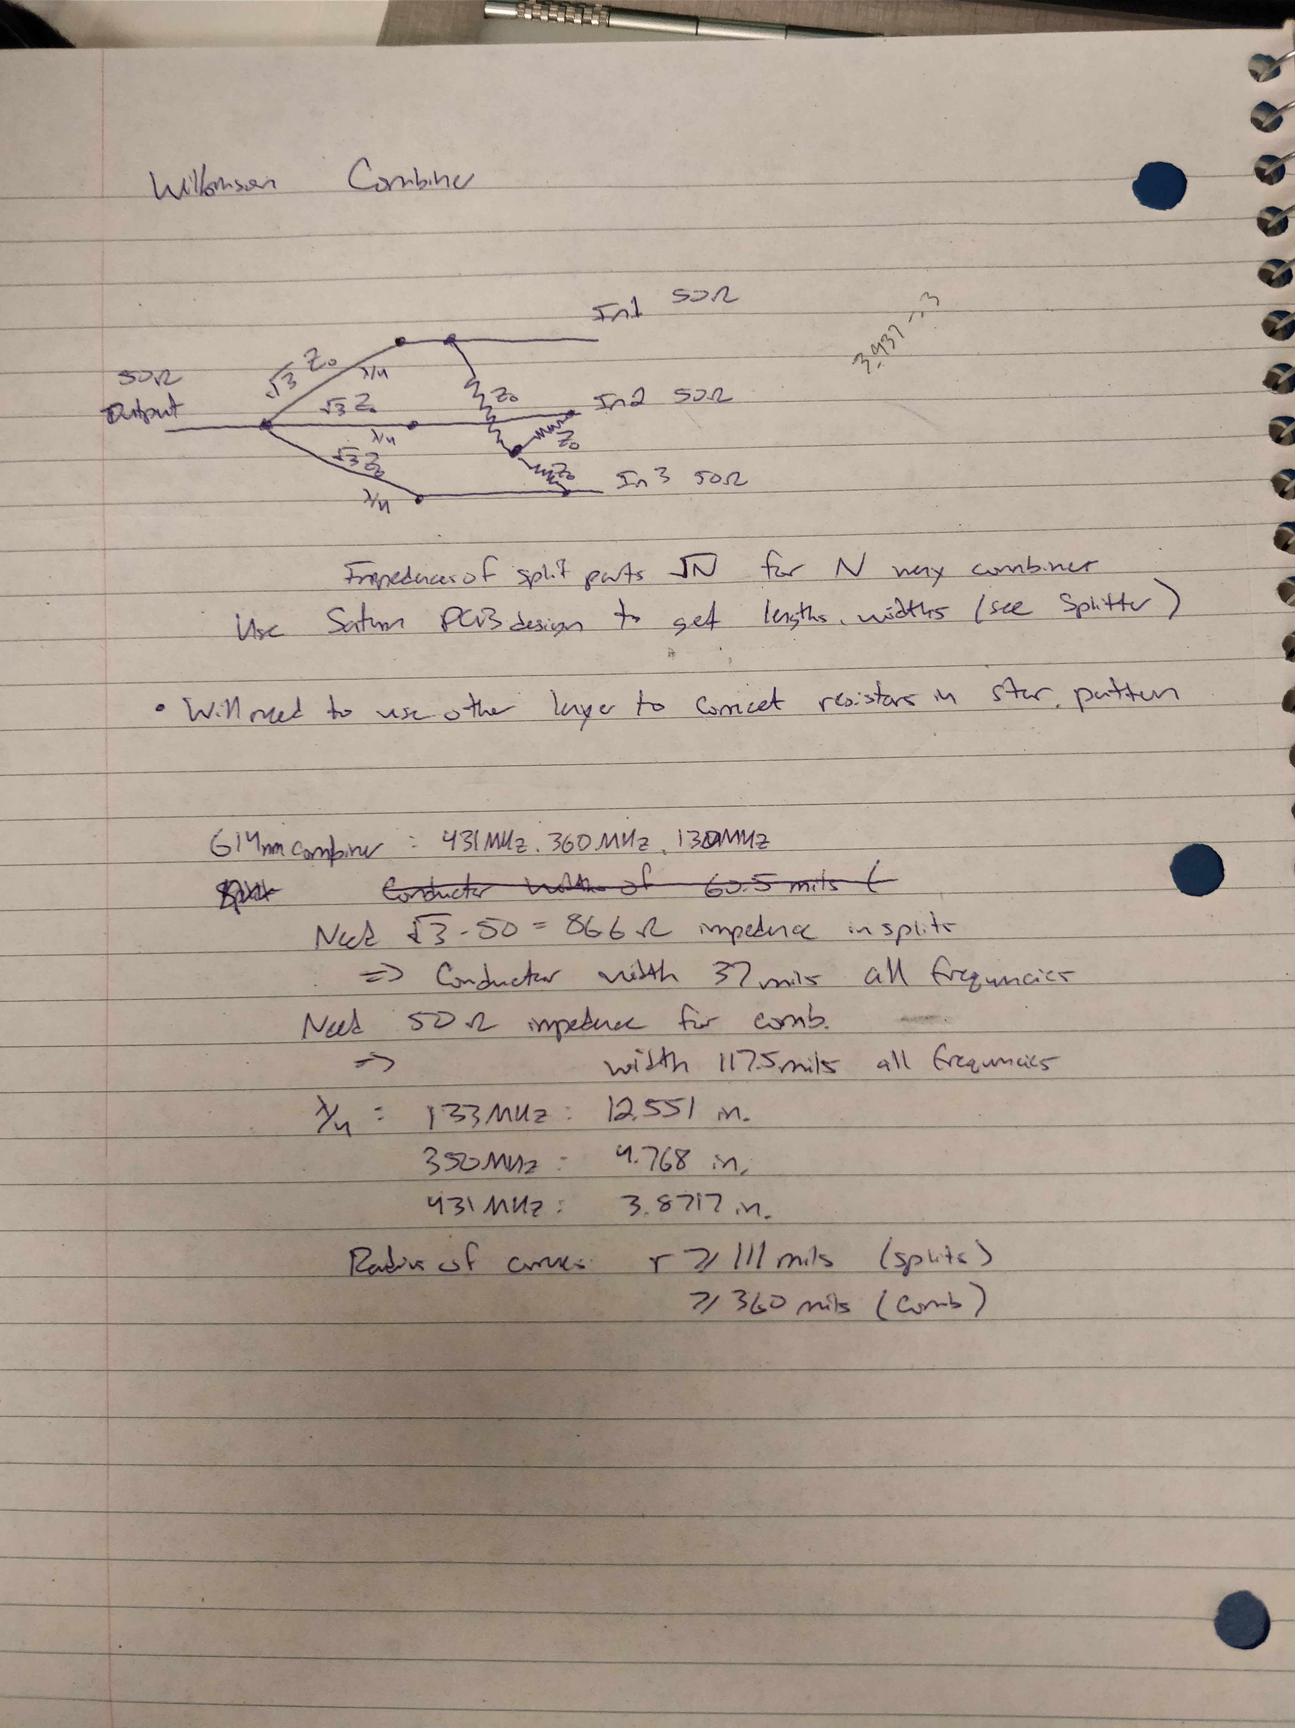

**Final Notes**

All RF designs should have “Fences” around the entire PCB board. These are a single grounded net(wire) on the top layer of the PCB with Vias connecting it to ground periodically. The screenshot of a x4 – 200MHz splitter is shown here. In this example, I was not able to fit fencing around ever part of the board.

